This is a complete guide to help you manage the installation and setup of the Theme that you just bought.

Thank you for purchasing our theme. We hope that you’ll find it easy to use and customize. Please read the following manual, because it covers almost all of the aspects needed about how to install and run the theme. We also provide several **video tutorials** that will show you how to **import the demo content** and how to work with our **page builder**. If you have questions that are not answered in this guide, please go to the support system, where your questions will be answered:

[**https://premiumcoding.zendesk.com/tickets/new**](https://premiumcoding.zendesk.com/tickets/new)

Please verify the documentation and FAQ before posting.

If you like the theme, please show your appreciation by taking the time to rate it.

## Getting Started

To install this theme you must have a working version of WordPress already installed. For information in regard to installing the WordPress platform, please see the WordPress Codex - http://codex.wordpress.org/Installing\_WordPress1.1

## Installing the Theme

After you have installed Wordpress, you have to install our Theme (Opus.zip). There are two ways of installing the Theme on your Wordpress:

* **FTP Upload:** Unzip the “opus.zip” file and upload the contents into the /wp-content/themes folder on your server. If you get an error while activating the Theme uploaded via FTP, please ensure that [transfer type is set to binary](http://premiumcoding.com/wp-content/uploads/2014/08/ftp-upload-opus.jpg).
* **Wordpress Dashboard:** Navigate to Appearance > Add New Themes >Upload. Go to browser, and select the zipped theme folder. Hit “Install Now” and the theme will be uploaded and installed.

Download the zipped theme pack to your local computer from themeforest and extract the ZIP file contents to a folder on your local computer. If you do not do that and install the first package directly you will get the following error:

**The theme is missing the style.css stylesheet**

So be sure that you are always installin the file called **"OPUS.ZIP"**

## Once the theme is uploaded, you need to activate it. Go to Appearance > Themes and activate Opus Wordpress Theme. After the theme is activated, you will be prompted to install the required plugins (you can do so automaticlly or manually).

## 01_opus_documentation.jpg

## Click on begin installing plugins and you will be able to install all neccessary plugins. If you need them later on, you can find them in the Recommended plugins directory in the package you installed from Themeforest.

## page-builder-premiumcoding - this is our plugin which adds shortcodes and page builder for the Theme (this is a must have)

## Revolution Slider - this plugin adds the Revolution Slider, it's a premium plugin from Codecanyon and is a plugin we will update when there are newer versions.

## Contact Form 7 - CONTACT FORM - this is a plugin that you will need of you want to add the contact form. Plugin can be downloaded from Wordpress repository at: <http://wordpress.org/plugins/contact-form-7/>

## Twitter Widget Pro - TWITTER PLUGIN - this is a plugin that you will need if you want to add the Twitter block (in our live demo the block just above the footer). Plugin can be downloaded from this website: <http://ran.ge/wordpress-plugin/twitter-widget-pro/>

## Demo Content - Theme looking like live preview

After activating the theme, you will notice that a new submenu item appeared called PMC Themes. In the submenu there are three options (PMC Page Builder, PMC Theme Options, PMC Import).

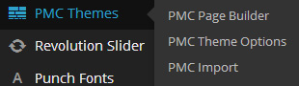

Start with **PMC Importer** if you wish to import the demo content. **Opus** comes with a special **one click demo install** that allows you to install demo content in a fast and convenient way. It is advised to use this demo importer on a **clean WordPress installation**. No more XML files and tedious demo installations. Simply choose the Skin that you prefer and set whether you wish to import Revolution Slider and Widgets and you are ready to go. Click on the link below to check the video tutorial that demonstrates just how fast and easy the demo installation is.

[**VIDEO TUTORIAL FOR PMC IMPORTER**](https://www.youtube.com/watch?v=68qVRnjhjEo)

## Please wait for the importer to be finished, do not interrupt it. Please note that this import is not perfect and it might fail sometimes, but it’s a good solution if you can’t or don’t know where to get started.

## If for some reason the installation fails, we have also prepared the XML files for content and Revolution Slider. In that case please follow these steps:

## Install the Opus WordPress Theme

## Install Revolution slider and our shortcode/builder plugin (found in the plugins directory in the files for download)

## Import Demo content which is included with the Theme (in DEMO CONTENT directory)

## To use it, go to Tools > Import > WordPress and upload the xml file, choose to import everything, hit the button and wait.

## Import Demo Settings for the Revolution Slider - demo content is in the same directory as the demo content for WordPress

## Set up the Home Page in Reading -> Settings

## You might also have to set Menus locations under Appearance -> Menu -> Menu Settings

## TIMEOUT ERROR

## If you get a timeout error while installing the demo content, you can contact your hosting provider and ask for a time increase (5 minutes should be enough on 99% of servers). Or you can follow the steps above and try to install the demo content manually. If you still have problems with installation, then please contact us via our support system at:

[**https://premiumcoding.zendesk.com/tickets/new**](https://premiumcoding.zendesk.com/tickets/new)

## PremiumCoding Page Builder

Premiumcoding Page Builder is a powerful WordPress plugin that allows you to create an unlimited number of template variations for use in your WordPress themes. This way you can have different header, content and footer for each of the pages you are creating. Start working with Page Builder by navigating to PMC Themes -> PMC Page Builder. We prepared two video tutorials that will help you get a hang of the plugin:

* [PremiumCoding Page Builder Video Tutorial - Basic Version (2:45)](https://www.youtube.com/watch?v=hu7JUzpaNOg)
* [PremiumCoding Page Builder Video Tutorial - Detailed Version (23:28)](https://www.youtube.com/watch?v=slEXn4QM1uo)

## Adding a Block

To add a block to the main building panel, drag the blocks from the Available Blocks container on the top of screen to the location you want on the building panel. The block will be automatically opened and you will be able to edit it to your liking.

## Resizing a Block

Depending on which block you’re currently editing, some blocks can be resized and some do not. To resize a block, simply hover on either sides of the block, a “Resize Handle” cursor icon will appear to indicate that the block is resizable. Click, and drag the resize handle to the width you like.

## Deleting a Block

There are two ways to delete a block.

* **Method 1** - Drag the block to the Available Blocks container.
* **Method 2** - Open the block to show its content, and on bottom left you should see an anchor link titled Delete which you can click to delete the block.

Please note that all changes will not be saved until you clicked the **Save Template** button.

## How to add the arrow below the block

Some of the blocks in our live demo have an arrow in **start blocks** that points down to the next block. For the block to have this arrow you need to add a class mainarrow to use custom class field. Screenshot below is demonstrating where exactly this is:

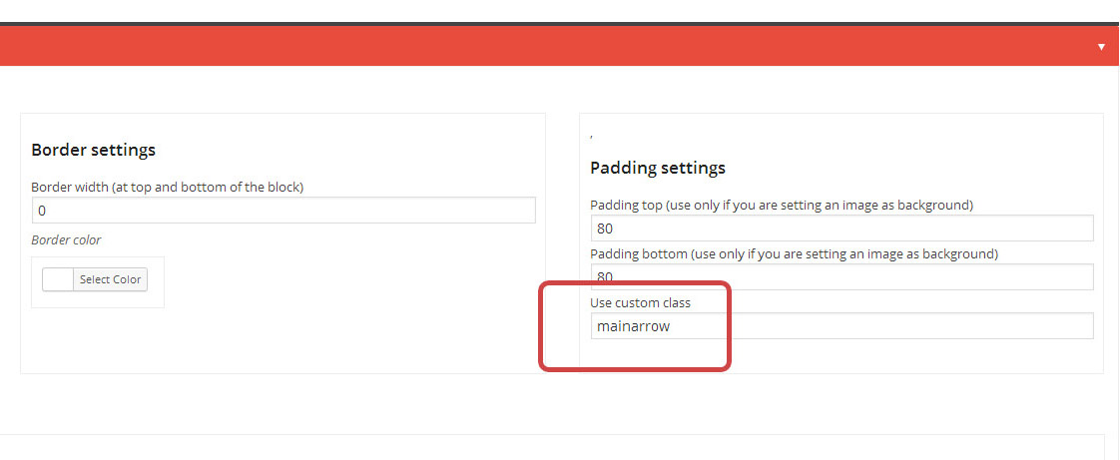

## How to set up Pages

Opus brings unique setting up of pages. With the help of our Page Builder it is possible to set different header, footer and body part for each Page you are creating. The process is as follows:

* Go to Pages -> Add new
* Under the page content you will notice a part titled PMC page builder options for this page
* Set Template for Body, Header and Footer
* You can leave the Footer and Header Values to Default to use the default header and footer
* Under Page Attributres be sure to set the Template to Template for Page Builder

Screenshot below is showing where these crucial parts are:

[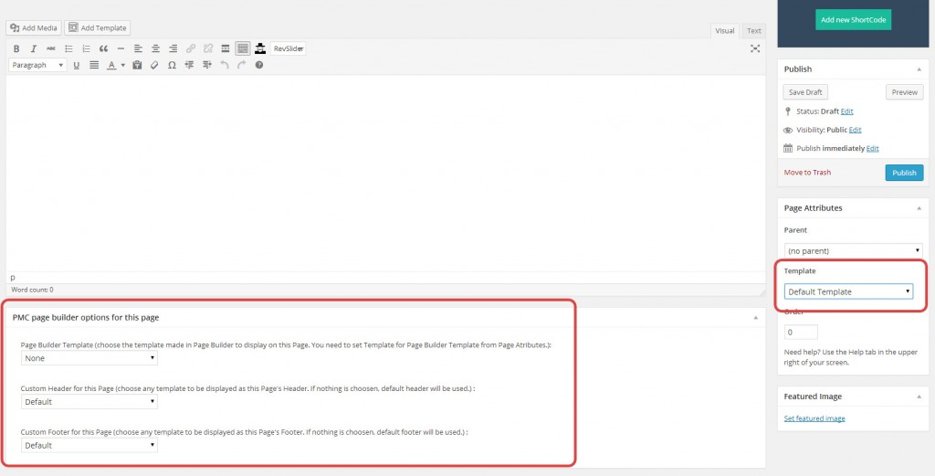](http://premiumcoding.com/wp-content/uploads/2014/05/page-setup-1024x521.jpg)

## How to make bigger notification and dark submenu

Our default front page uses a bit different notification block and submenus are dark not white. To achieve this you need to add the following class in the start block under use custom class field: **smallheader.** This makes for the different structure of **NOTIF & MENU** block (phone, email, time) and for the **dark submenu** of the main menu. Check the Screens below.

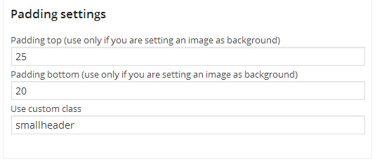

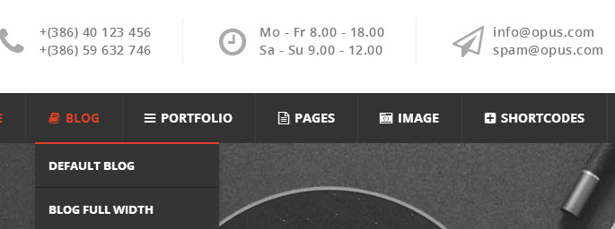

## Theme's Options

After activating the theme, you will notice that a new submenu item appeared called PMC Themes. In the submenu there are three options (PMC Page Builder, PMC Theme Options, PMC Import). To start customizing the Theme's settings click on PMC Theme Options.

## General Settings

**Logo, favicon and custom menus** are set and added. Upload your logo, retina logo and custom logo for scroll if you need one (useful if you have transparent menu and need logos in different colors). You need to also upload a double sized logo for retina displays (be sure it is named like this opus-logo1@2x.png with the @2x at the end).

**Header height, menu and logo** position are set here so you can perfectly place them (if you have a large logo you will have to change those settings).

**Responsive Mode** can be disabled if you uncheck it.

**Icon link for portfolio** - this is the link on single portfolio pages where next and previous project links are placed (link to your main portfolio in most cases).

**Default Footer and Header** - these are the defaults templates for header and footer. Please note that you can set different footer and header templates for each page, but these are the defaults that will be used in case nothing is chosen at the page.

## Content Settings

All that is set here are the sponsors. Upload and add sponsor images and then add the sponsors block in Page Builder.

## Styling Options

**Main Theme Color** - color that is set throghout the Theme (red is default color for Opus Theme). Once you change the color please not that not all aspects of the site will change (some color will still be red). This is because on some parts of the Theme **shortcodes** are used. You need to change this manually as it gives you much more **freedom in color selection** (it can be anything independant from theme's main color).

**Color of Main Titles of blocks** (on home pages) can be changed directly in the **Block Start** block in the Page Builder. This means you can have **different colors** of Titles for **each block,** making it very versatile.

**Lower Border Color** - color that is set for lower borders (buttons, etc.)

**Boxed version** - if you need a boxed version, check it here and then set the background color or image.

**Custom Style** - if you need to change CSS for certain parts of the Theme you can add it here (so you don’t have to edit the style.css).

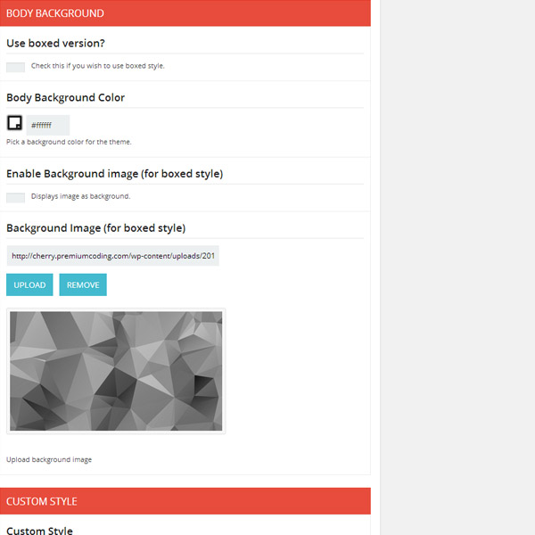

## Typograhy

Set typography for all main text elements (menu, headings and body). Below settings for each heading (1-6) can be set specifically.

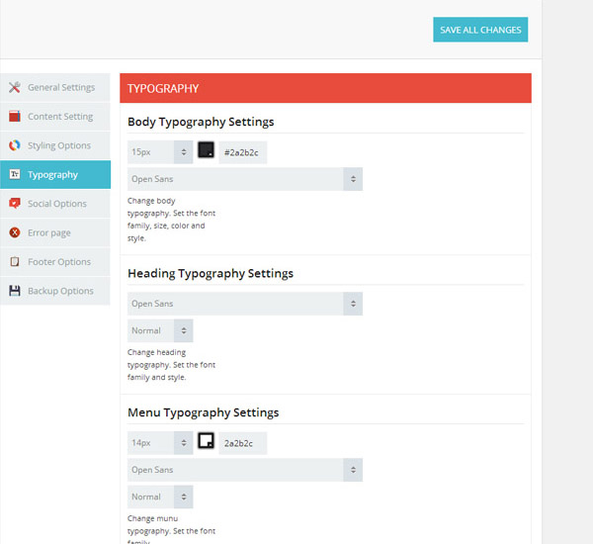

## Social Options, Error Page and Footer Options

Last three tabs are very straightforward. In **Social tab** you can set your own social icons which are then added with the **Social Block** in Page Builder.

**Error Page** defines the text on the **404 page not found.** This page appears everytime a user misclicks or comes to a page that does not exist.

**Footer Options** set the text that is found at the very bottom of the Theme (below the footer part with widgets). Usually copyright information is entered here.

## Backup Options

If you need to backup your theme’s options or import them later on, you can do that in this tab. Copy the code in text field to a TXT file so you can use it later on if needed.

Import works very simple. Copy and paste the JSON code in the **Transfer Theme Options Data Field** and click Import Button.

## Setting up the Home Page

Opus brings unique setting up of pages. With the help of our Page Builder it is possible to set different header, footer and body part for each Page you are creating. The process is as follows:

* Go to Pages -> Add new
* Under the page content you will notice a part titled PMC page builder options for this page
* Set Template for Body, Header and Footer
* You can leave the Footer and Header Values to Default to use the default header and footer
* Under Page Attributres be sure to set the Template to Template for Page Builder

After you decide what page do you want to use, go to **Settings > Reading** and in the Front page displays choose a static page, then select your just created page. After this, you should change the **Blog pages** show at most value from 10 to 5 posts. This theme works best with this setup. Hit “Save Changes” and you’re done.

Next, you should setup your **permalinks** to look pretty. Please go to Settings > Permalinks, choose the Custom Structure, and use this: /%category%/%postname%/

[READ THIS](http://codex.wordpress.org/Using_Permalinks#Permalinks_without_mod_rewrite) about permalinks on Windows Servers!

## Navigation and Menu Settings

The last step before you can start working with the new theme is to create your menu. Go to Appearance > Menus and you will see a panel where you can create new menus. Create one, add your created pages to it (from the left side panels) and save it. Now set the locations for the menu that you just created. The main menu will probably be set at Main Menu, Responsive Menu and Scroll Menu. If you set the Home Page as One Page you will need to set a different menu for the Inner Pages (like Blog, Portfolio, etc.). This Menu will be set to Single Page Menu and Responsive Single Page Menu.

## Customizing Menu Item

**The Navigation Label** – this field specifies the title of the item on your custom menu. This is what your visitors will see when they visit your site/blog.

**The Title Attribute** – this field specifies the Alternative (‘Alt’) text for the menu item. This text will be displayed when a user’s mouse hovers over a menu item.

* Click on the arrow in the top right-hand corner of the menu item to expand it.
* Enter the values for the Navigation Label and Title Attribute that you want to assign to the item.
* Click the Save Menu button to save your changes.

## Creating Multi Level Menus

When planning the structure of your menu, it helps to think of each menu item as a heading in a formal report document. In a formal report, main section headings (Level 1 headings) are the nearest to the left of the page; sub-section headings (Level 2 headings) are indented slightly further to the right; any other subordinate headings (Level 3, 4, etc) within the same section are indented even further to the right.

The WordPress menu editor allows you to create multi-level menus using a simple ‘drag and drop’ interface. Drag menu items up or down to change their order of appearance in the menu. Drag menu items left or right in order to create sub-levels within your menu.

To make one menu item a subordinate of another, you need to position the ‘child’ underneath its ‘parent’ and then drag it slightly to the right.

If you need to backup your theme’s options or import them later on, you can do that in this tab. Copy the code in text field to a TXT file so you can use it later on if needed.

**How to position the sub-menu item**

* Position the mouse over the ‘child’ menu item.
* Whilst holding the left mouse button, drag it to the right.
* Release the mouse button.
* Repeat these steps for each sub-menu item.
* Click the Save Menu button in the Menu Editor to save your changes.

## How to set up the Navigation

When going to Appearance / Menus you will see the structure of the templates navigation. You can easily edit menu labels, and move them using drag and drop. On the left column you have the possibility to add menu items using “custom links”, “pages” or “categories”. The newly added item will appear at the bottom of the menu structure and can be moved to its desired location. Make sure to always save the menu after making changes.

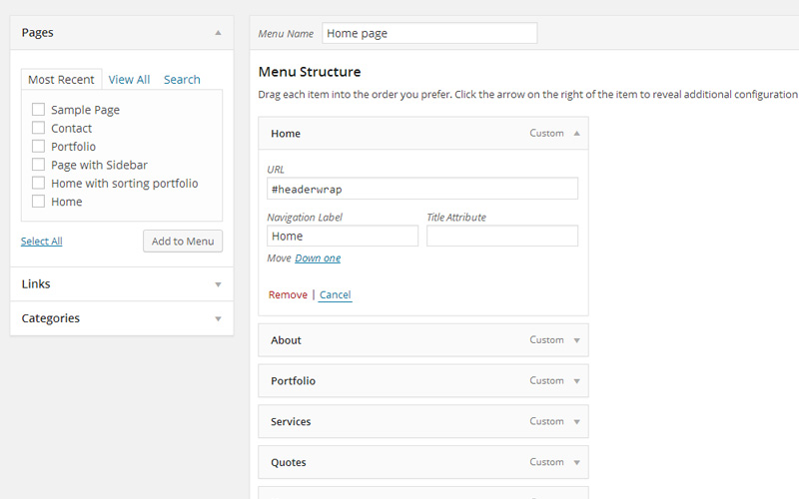

Be careful to set URL correctly if you wish to have a One Page Theme (like #headerwrap). These have to be the same as ID’s you set in the page builder (for the menu to properly scroll to the correct block.

The Screen Options allow you to choose which items you can use to add to a menu. Certain items, like Posts are hidden by default.

* Locate the pane entitled **Pages.**
* Within this pane, select the View All link to bring up a list of all the currently published Pages on your site.
* Select the Pages that you want to add by clicking the checkbox next to each Page’s title.
* Click the Add **to Menu button** located at the bottom of this pane to add your selection(s) to the menu that you created in the previous step.
* Click the **Save Menu** button.

## Deleting Menu Item

* Locate the menu item that you want to remove in the menu editor window
* Click on the arrow icon in the top right-hand corner of the menu item/box to expand it.
* Click on the Remove link. The menu item/box will be immediately removed.
* Click the Save Menu button to save your changes.

## How to add the Mega Menu

The first level menu needs to have **CSS class pmcbig**. After that you set up the 4 columns (first level sub menu), they need to have **CSS class set to pmcmenutitle**. Now you can add menu items to the second level (in our case there is 5 items in each column). The second image demonstrate how to set them up. If you want to add font awesome icons be sure to fill the proper label. There is a link which will lead you to the list of all the icons that can be used.

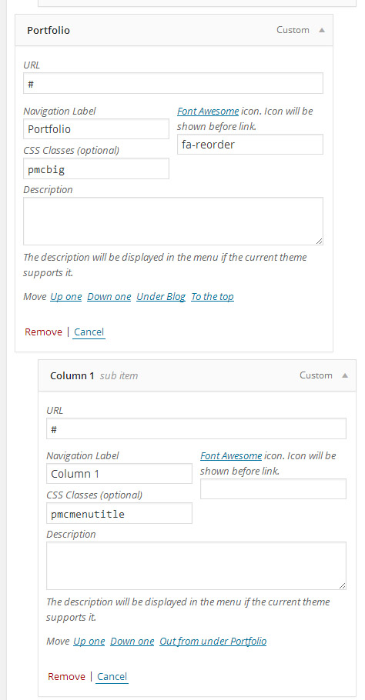

## How to add the Image Menu

Image menu can be added directly in the menu item. Image below demonstrate which fields need to be set up and how.

**URL:** http://opus.premiumcoding.com/creative-bike-design/

**NAVIGATION LABEL:** <span class="pmcmenutitleimage">Creative Bike Design<img src="http://opus.premiumcoding.com/wp-content/uploads/2014/03/post-opus-1.jpg" alt="menu image"> </span>

Class needs to be **pmcmenutitleimage** and then you set the Title and under img src you set the path to the image. Also you need to add the class bigimagemenu to the parent menu item.

## Setting the Home Page as One Page Theme

The default setting of the Menu in the Demo you will import is for Multiple Pages. If you wish to have One Page Theme you need to set up the menu differently. But first you need to set proper anchors in **start blocks** of page builder template. Check the Screenshots below of how and where this need to be set up.

Once this is set go to **Appearance -> Menus** and add add the menu item as a **custom link.** Under URL write #about to point to the anchor link you created in start block. Check the Screenshot below to see how it is set up.

## Settings in the Start Block

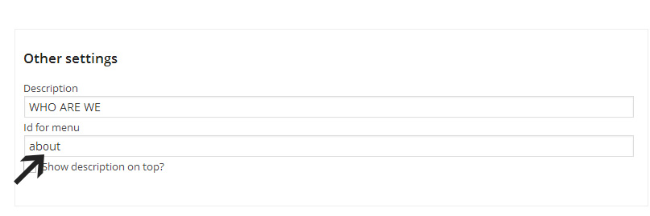

## Settings in the Appearance -> Menus

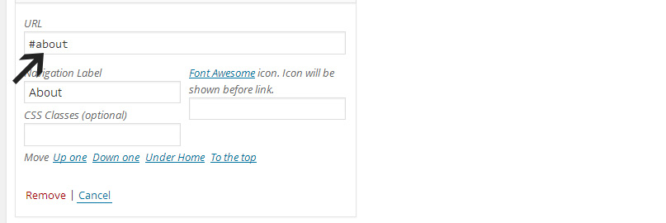

## Adding Content

## Adding Posts

These are the default steps that you need to do in order to add a blog post:

* Go to Posts > Add New
* Enter a title and some content.
* Select a post category.
* Add some relevant tags.
* Choose a post format from the right. There are a few types of custom

formats that can be used (Standard, Link, Gallery, Video, Audio).

* Setup the content of the post format(either a gallery, a link, an image, a

quote, an mp3 or a video).

* Insert all of your remaining content in the content area. You can have

images, paragraphs, etc..

* Write a few words excerpt(it is good for search results and SEO to have an

excerpt, no matter what kind of content do you have in your post).

* Hit “Publish” and you’re all done.

Specialty of Opus is that you can **change header and footer** section for each post individually (if you need to). Both are set to Default at the start. You can change them to any template you created in the Page Builder. This is set under **Custom Post Top and Bottom Content** just below the post content.

**Recommended size** of Post's featured image is 800x490.

## Adding Pages

* Go to Pages > Add New
* Enter a title and some content.
* Select a page template or leave the default(more on this just after).
* Select a layout for the page. Each page can have a custom sidebar or not.
* Write a few words excerpt(it is good for search results and SEO to have an

excerpt, no matter what kind of content do you have in your page).

* Hit “Publish” and you’re all done.

## Page Templates

Opus works a bit differently when it comes to setting up Templates for Pages. Since it uses a Page Builder with which you first build the Templates (Pages) there is less options for Page Templates under **Page Attributes.**

* + 1. **Default Template**

This is the default template and it outputs exactly the content of the page, without any modifications. This is a full width Template.

* + 1. **Default Template with Sidebar**

This is the default template and it outputs exactly the content of the page, without any modifications. This is Template with Sidebar on the right.

* + 1. **Template for Page Builder**

This is the Template used for pages built with **Page Builder**. Under the page content you will notice a part **titled PMC page builder options for this page**. Set Template for Body, Header and Footer. You can leave the Footer and Header Values to Default to use the default header and footer of the Theme. Under Page Attributres be sure to set the Template to Template for Page Builder.

Screenshot below is showing where these crucial parts are:

[](http://premiumcoding.com/wp-content/uploads/2014/05/page-setup-1024x521.jpg)

## Adding Portfolio Items (Projects)

**1.** Go to Portfolio > Add New

**2.** Enter a title and some content.

**3.** Choose one or more categoies. This is a must, because these categories will be

used to filter projects in the grid.

**4.** Set the featured image. The size of the featured images depends on the

number of columns that you want to use and whether you want this to be

retina ready or not, but as a general rule, you should upload images as large as

possible and let the theme do the cropping. The recommended size is 700x600 (this is the size we use in the Theme).

**5.** Write some content.

**6.** Setup the slider and project options (more info below).

**7.** Write a few words excerpt(it is good for search results and SEO to have an

excerpt, no matter what kind of content do you have in your page).

**8.** Hit “Publish” and you’re all done.

## Project Details

Under the project content is a section titled Portfolio Entry Options. This is where you set all the details about the project like:

* Link to the Project
* Author of the Project
* Date of the Project
* Customer for which the Project was done
* Required Skills

## Project Gallery

Gallery or Slideshow is created simply by uploading the images to the post via Media Upload (**Add Media Button**). You can check which images are in the slideshow by clicking on Media Library and then select **Uploaded to this post** from the list (check the screenshot below).

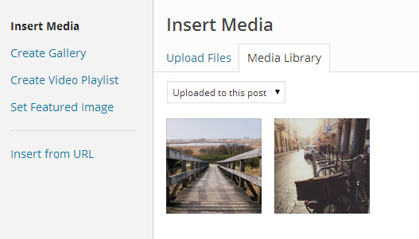

## Shortcodes

Opus is full of shortcodes! Inside our custom page builder you can achieve whatever you want, as everything is easy to use, customize and understand. If you imported the demo content you will also get an import of all the Pages with Shortcodes from the live demo (under menu Shortcodes). Below is the list of all those shortcodes with short description and the code.

## Accordion and Toggles

**LINK:** http://opus.premiumcoding.com/shortcodes-accordion-toggles/

This is a simple accordion shortcode, available in three different styles.

[accordion]

[atab title="First Accordion Title"]Content... [/atab]

[atab title="Second Accordion Title"]Content... [/atab]

[atab title="Third Accordion Title"]Content... [/atab]

[/accordion]

[tabgroup]

[tab title="First Title"]Content... [/tab]

[tab title="Second Title"]Content... [/tab]

[tab title="Third Title"]Content... [/tab]

[/tabgroup]

[toggle title="Toggle title..."]Content... [/toggle]

[toggle title="Toggle title..."]Content... [/toggle]

[toggle title="Toggle title..."]Content... [/toggle]

## Alert Boxes

**LINK:** http://opus.premiumcoding.com/shortcodes-alert-boxes/

Simple alert boxes to notify your visitors about certain events.

[info]Information box...[/info]

[question]Question box...[/question]

[error]Error box...[/error]

[success]Success box...[/success]

## Boxed Content

**LINK:** http://opus.premiumcoding.com/shortcodes-boxed-content/

Sometimes you need content to stand out a bit more and that's when Content Boxes come in handy.

[pmc\_box background\_color="#DF5148" border\_color="#DF5148" text\_color="#ffffff" ]Content... [/pmc\_box]

## Columns

**LINK:** http://opus.premiumcoding.com/shortcodes-columns/

Columns can be very important when it comes to content presentation. You have a lot of possibilites, from 2, 3, 4 and 5 columns to combinations of different widths.

[half]

Content...

[/half]

[half\_last]

Content...

[/half\_last]

All other shortcodes work in the same principle:

* one\_third - one\_third\_last
* one\_fourth - one\_fourth\_last
* one\_fifth - one\_fifth\_last

Other possible combinations are:

* one\_fourth - three\_fourths\_last
* one\_third - two\_thirds\_last

## Buttons

**LINK:** http://opus.premiumcoding.com/shortcodes-buttons/

Buttons are a very useful UI element for any Theme. We have prepared several different variations for a better feeling.

* [button\_icon link="http://premiumcoding.com" background\_color="#DF5148" border\_color="#C53D35" text\_color="#fff" icon="fa-link" ]Read more link Button[/button\_icon]
* [button\_icon link="http://premiumcoding.com" background\_color="#DF5148" border\_color="#C53D35" text\_color="#fff" icon="fa-spinner fa-spin" ]SPINNING BUTTON[/button\_icon]
* [button\_round link="http://premiumcoding.com" background\_color="#DF5148" border\_color="#C53D35" text\_color="#fff" ]VIEW MORE[/button\_round]
* [button\_simple link="http://premiumcoding.com" background\_color="#DF5148" border\_color="#C53D35" text\_color="#fff" ]DARK RED BUTTON[/button\_simple]
* [button\_social link="https://twitter.com/premiumcoding" background\_color="#32CCFE" border\_color="#18ACDC" text-color="#fff" icon="fa-twitter" ]Follow us on Twitter[/button\_social]
* [button\_simple\_double link="http://premiumcoding.com" background\_color\_double="#C53D35" background\_color="#DF5148" text\_color="#fff" ]Double simple button[/button\_simple\_double]
* [button\_icon\_double link="http://premiumcoding.com" background\_color\_double="#C53D35" background\_color="#DF5148" text\_color="#fff" icon="fa-picture-o" ][/button\_icon\_double]

Buttons can be learned much easier by checking our Live Demo or if you import the demo content. Above are examples by type (one for each type of buttons).

## Count Blocks

**LINK:** http://opus.premiumcoding.com/shortcodes-count-blocks/

Count Blocks present simple content in a more creative and playful way. Below is the shortcode for the Count Block.

[count\_block background\_color="#fff" text\_color="#2a2b2c" icon="fa-clock-o" number="365" ]DAYS TO MAKE IT[/count\_block]

## Google Maps

**LINK:** http://opus.premiumcoding.com/shortcodes-google-maps/

Google Maps can be a very important part of your website. You can set width, height, zoom, custom pin (from your image) and map style.

[google\_map zoom="12" width="780" height="400"  address="Slovenia, Ljubljana" bounce="false" image=" google-map-pin1.png"][/google\_map]

**Available Map Styles**

* greyscale
* blue
* bubbly
* gowalla

## Iconography

**LINK:** http://opus.premiumcoding.com/shortcodes-iconography/

Icons are awesome and use of them on website always animates the site a bit. We are proud to announce that with our shortcodes you have access to all 369 icons from Font Awesome. All icons come in 3 different sizes (Small, Medium and Big) and you choose the color directly in the shortcode for each icon individually, which means you can have unlimited color schemes.

* [pmc\_icon link="http://premiumcoding.com" background\_color="#DF5148" border\_color="#C53D35" icon="fa-coffee" size="medium"][/pmc\_icon]
* [pmc\_icon link="http://premiumcoding.com" background\_color="#DF5148" border\_color="#C53D35" icon="fa-pencil" size="big"][/pmc\_icon]
* [pmc\_icon link="http://premiumcoding.com" background\_color="#DF5148" border\_color="#C53D35" icon="fa-microphone" size="small"][/pmc\_icon]

You can set link, background color, border color, size and icon from [Font Awesome](http://fortawesome.github.io/Font-Awesome/icons/).

## Images and Videos

**LINK:** http://opus.premiumcoding.com/shortcodes-images-and-videos/

Animated images add some motion on your website. You can set the image to appear from left, right, top and bottom.

* [pmc\_image link="http://premiumcoding.com" image="image -1.jpg" icon="fa-gear" animated="fadeInLeft" ]

## Lists

**LINK:** http://opus.premiumcoding.com/shortcodes-lists/

Normal bullets for lists can be boring and if you need something more creative, then you can choose between 12 custom bullets for lists.

[list\_link]

* list link item...

[/list\_link]

**List of all bullets**

* list\_image
* list\_link
* list\_star
* list\_settings
* list\_ribbon
* list\_plus
* list\_comment
* list\_arrow
* list\_circle
* list\_arrow\_point
* list\_tick

## Premium Image Boxes

**LINK:** http://opus.premiumcoding.com/shortcodes-premium-image-boxes/

Premium Image Boxes are containers for images that reveal title and text on hover. They are meant to add extra creativity to the Theme if you need it. There are four different directions into which the image is able to “travel”.

[image\_square\_1 link="http://premiumcoding.com" image="image -1.jpg" border\_color\_1="#000" animation="bottom\_to\_top" title="HEADING" ]Content... [/image\_square\_1]

You can set link, image, border color, animation direction, heading and content. You can choose between following animations:

* bottom\_top\_top
* top\_to\_bottom
* left\_to\_right
* right\_to\_left

## Premium Rotating Circles

**LINK:** http://opus.premiumcoding.com/shortcodes-premium-rotating-circles/

Premium Rotating Circles are circled containers for images that add extra creativity to the Theme if you need it. Be sure to add two different border colors for the effect.

[image\_circle\_1 link="http://premiumcoding.com" image=" image- 1.jpg" border\_color\_1="#E74C3C" border\_color\_2="#333" title="HEADING" ]Content... [/image\_circle\_1]

## Pricing Tables

**LINK:** http://opus.premiumcoding.com/shortcodes-pricing-tables/

Pricing tables can be an important part of the website for many Businesses. We added a few different variations. As you can notice from the shortcode below you can set different background colors for each line which makes the tabels very customizable.

[**pricing\_tabels** width="33.3%" highlighted="false" price="$49.99" price\_title="per year" background\_color="#DF5148" title="STARTING PACKAGE" button="SIGN UP" button\_link="http://premiumcoding.com"]  
[**pricing\_options background\_color**="#DF5148" ]10GB Disk Space[/**pricing\_options**]  
[**pricing\_options background\_color**="#DF5148" ]200GB Bandwidth[/**pricing\_options**]  
[**pricing\_options background\_color**="#DF5148" ]20 Domains[/**pricing\_options**]

[**pricing\_options background\_color**="#DF5148" ]Free Support[/**pricing\_options**]

[**pricing\_options background\_color**="#DF5148" ]Unlimited Email Accoun[/**pricing\_options**]  
[/**pricing\_tabels**]

## Progress Bars

**LINK:** http://opus.premiumcoding.com/shortcodes-progress-bars/

Progress bars are a good way to display your skills or what is the completion status of certain project.

[progressbar progress=60 color=#DF5148]Illustration Making[/progressbar]

## Quotes

**LINK:** http://opus.premiumcoding.com/shortcodes-progress-bars/

Quotes are parts of text that are distinguished from other content and are used as quotations from visitors, buyers, etc.

[pmc\_quote border\_color="#ECF0F1"]Content...

John Doe, CEO PremiumCoding

[/pmc\_quote]

## Skills Charts

**LINK:** http://opus.premiumcoding.com/shortcodes-skills-charts/

They are used to display the knowledge of certain skills or to display progress on projects or other statuses.

[pmc\_progress\_circle progress="88" background\_color="#2a2b2c" progress\_border="#DF5148" border\_color="#ddd" radius="100"]ILLUSTRATIONS[/pmc\_progress\_circle]

## Videos

**LINK:** http://opus.premiumcoding.com/shortcodes-videos/

Adding videos is simple, just add the iframe code in Text editor and you are done. Just be sure to add this code in HTML mode of your post editor.

VIMEO

<iframe src="//player.vimeo.com/video/42327250" width="780" height="438" frameborder="0" allowfullscreen="allowfullscreen"></iframe>

YOUTUBE

<iframe src="//www.youtube.com/embed/CjQ2jGUNSck" width="780" height="586" frameborder="0" allowfullscreen="allowfullscreen"></iframe>

## Tips and Tricks

## Child Theme

A WordPress child theme is a theme that inherits the functionality of another

theme, called the parent theme. Child theme allows you to modify, or add to the

functionality of that parent theme. Instead of modifying the theme files directly, you can create a child theme and override within.

You will find child Theme version in the package you downloaded from Themeforest

in the directory called CHILD-THEME.

More information about Wordpress child themes can be found on [Wordpress Codex.](http://codex.wordpress.org/Child_Themes)

## SEO Advices

The theme is built in a way to be SEO friendly, by emphasizing titles with heading tags, having the content before anything else, stripping out useless content, fast loading, setting titles in the header for better crawling, etc.. But you have to remember that Content is King! So you shouldn’t blame the theme because your website doesn’t appear in search engines. You should always focus on providing good content and in this way, your website will definitely look great in search engines. Also, you should always install a popular SEO plugin which will make the most of keywords and descriptions.

We recommend using the [Yoast Plugin for SEO](https://yoast.com/wordpress/plugins/seo/).

## Make your website run faster

## Get a good hosting

You may not think that this is important, but if you want your site to display really fast you need to get a good hosting. This is the first step in having a fast site, which also translates into more views, which also translates into a better SEO.

Below are some hosting companies that we recommend:

* [Media Temple](http://mediatemple.net) - if you want a premium WordPress hosting which is easy to manage and works pretty well, this is a good choice to host your website on.
* [040 Hosting](https://www.040hosting.eu/) - this is the hosting that we use and it's top notch. Fast servers and fast & reliable support.
* [WPEngine](http://wpengine.com) - not as cheap as the two examples above, but if you really want an incredibly fast website, WPEngine is the way to go. With it you don’t have to worry about security, caching, updates, etc. Everything is handled by a great theme of professionals ready to help you with everything.

## Optimize images

Always optimize/compress your jpeg images before uploading them to the server /your Wordpress. Large images should be compressed at around 80%-90% image quality and you should also try to limit the use of lossless image files (uncompressed pngs).

## Use a caching plugin

I can’t recommend enough the necessitiy of a good caching. If you use a managed hosting such as WPEngine you don’t need this. But if you are using ASO or MT or any other hosting you need to cache your content. For this purpose, i recommend [W3 Total Cache](https://wordpress.org/plugins/w3-total-cache/)! It’s a great and easy to use plugin, and with only a bit of work you can double your site’s speed.

## FAQ

## Theme's options seem disabled

First try reseting theme options. If this doesn’t work send us your login details.

## What to do if I get error upon Theme Activation

If you receive the following error:

**Parse error: syntax error, unexpected $end in …/wp-content/themes/opus/admin/theme-options.php on line 1**

This happens if you install the Theme via FTP and the transfer type is not set to **binary**. So set the transfer type to binary as can be [seen on this link](http://premiumcoding.com/wp-content/uploads/2014/08/ftp-upload-opus.jpg).

## How to change croping size of images

Opus uses several different image sizes which are listed below:

* Revolution Slider - 1920 x 550 (can vary if you use different Slider size)
* Blog - 800 x 490
* Portfolio - 700x600

These are the general sizes used. Different sections of the Theme uses different croping. To change it, open functions.php and at the top you will notice code like:

**add\_image\_size( 'homePort', 393 ,300, true );**

After you change the size of the image, you need to [regenerate Thumbs](https://wordpress.org/plugins/regenerate-thumbnails/) for the changes to be visible.

## How to add the arrow in the block

Some of the blocks in our live demo have an arrow in start blocks that points down to the next block. For the block to have this arrow you need to add a class mainarrow to use custom class field. Screenshot below is demonstrating where exactly this is:

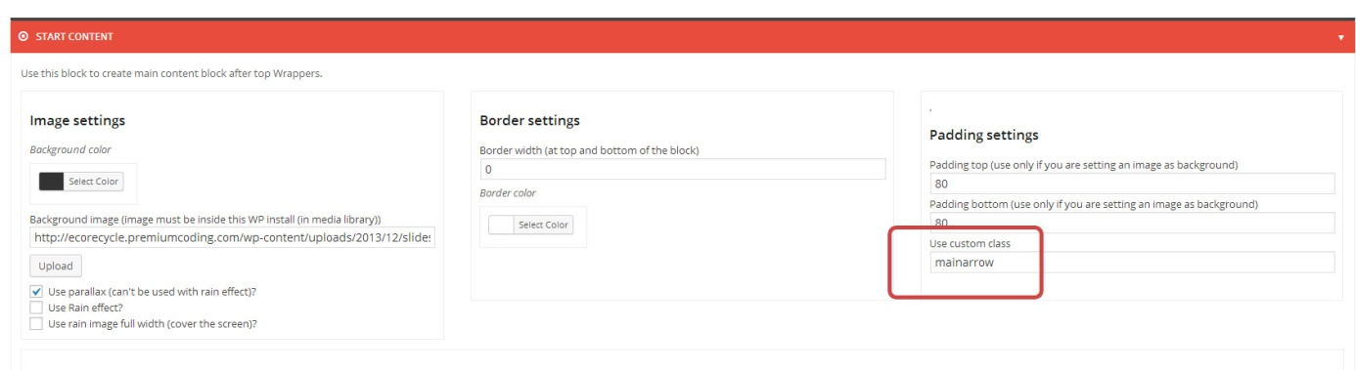

## How to properly set up Video Post

**Video Post -** Go to the post and set it to video format, then set the field just below the post text that says: Video URL(\*required). Also check the Screenshot below that is showing where you have to set the link:

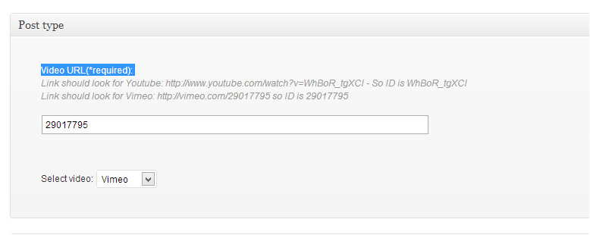

## What to do if Submenu is hidden below content

Open Start Block where the menu block is and add the following class to **use custom class** field - **extramenu**

## Theme's settings are not saving

First try to save settings twice, that will help on some servers/cases. If it is not working then try this:

Go to your theme’s directory and set CSS directory’s permission to 755. Then go inside the folder and set permissions of all php files to 755. If it is not permissions issue and is still not working, then drop us an email.

## How to completely remove responsive mode

If you don’t wish to have responsive mode and unchecking in theme’s options doesn’t have the desired effect, you can easily remove all the responsive features. ForIphones and Ipads it is enough to simply remove one line from header.php. Open header.php and remove the line:

<meta name=”viewport” content=”width=device-width, initial-scale=1, maximum-scale=1″ />

or other mobile devices you need to remove all the css that is used for media queries. Open style.cssand go almost to the end of it where the following line is:

@media screen and (min-width:0px) and (max-width:1180px)

Now delete everything that is beyond this line in style.css (including this line) up until CUSTOM CSS. Do not delete this last part, since the custom css box from theme’s options is included here. The responsive part is now completely removed and your website will be seen in full on mobile devices.

## The theme is missing style.css stylesheet

If you get this error message while uploading your Theme to Wordpress it means that you are uploading the whole package you downloaded from Themeforest. You need to uninstall the package and install the file called **Opus.zip**. This is the Theme.

## How to make bigger notification and dark submenu

Our default front page uses a bit different notification block and submenus are dark not white. To achieve this you need to add the following class in the start block **smallheader.** This makes for the different structure of **NOTIF & MENU** block (phone, email, time) and for the dark submenu of the main menu.

## How to update your Theme

Below is a short guide of how to update your Theme.

* First and best practice is to **make a backup**, download your current theme to your desktop via ftp. After that delete theme from WordPress.
* Go to themeforest, to your downloads page, this link precisely: **http://themeforest.net/downloads** and download Opus theme
* Upload the new version of theme **via your WordPress dashboard** or via ftp and that's it.

## How to add search widget to header area

If you need a **search** in your header section you can add it with **Widgets Block**. But first you need to create a custom sidebar. Procedure is as follows:

* Go to PMC Theme Options -> General Settings.
* Create **new Custom Sidebar** (name it Search Bar for instance).
* Now go to Appearance -> Widgets and add **Search widget** to that Sidebar.
* Select the appropriate Template in the Page Builder.
* Add widgets block to where you would like to have the search bar.
* If you are adding it next to NOTIF & MENU block, be sure that the right side of this block is set to be empty (On right side display Social icons or Menu should be set to none).
* Check the screen below to see how it looks in the page builder and on the Theme.

**PAGE BUILDER**

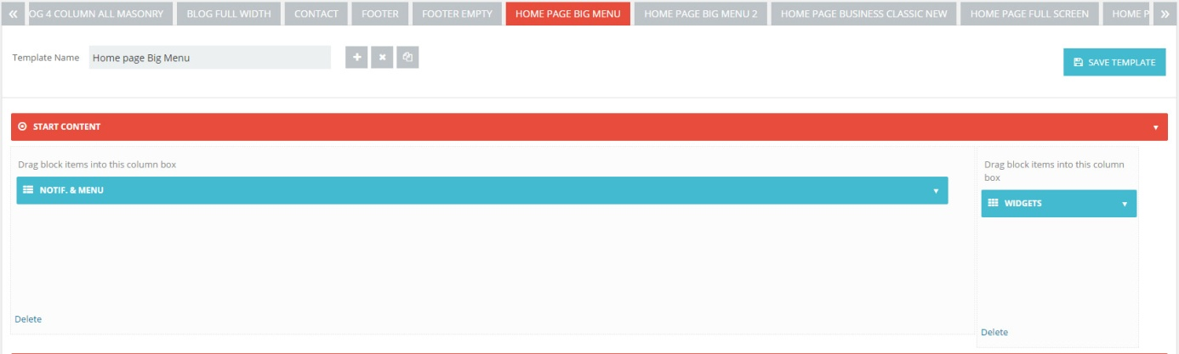

**ON THEME**

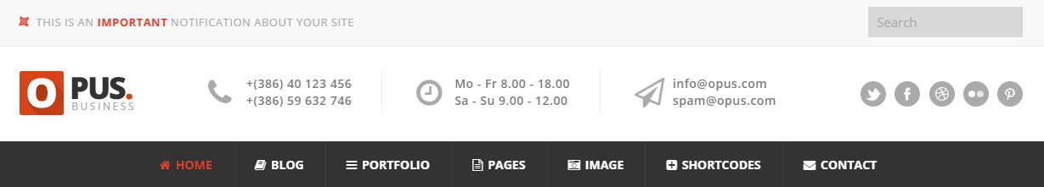

## How to add Fonts

If you don't see all fonts properly (like handwriting font on Slideshow), it means you have to add them via **Punch Fonts** (addon of Revolution Slider). The procedure is as follows:

* Go to Punch Fonts (at the left bottom of dashboard)
* Click Add New Font
* Set handle name (this is just an alias so you can set any name you want)
* Set Parameter, for fonts in our Theme it should be:
  + **Open+Sans:400,600,700,800**
  + **Dancing+Script**

## Custom Work

Please remember that WordPress themes are purchased as-is. If you want to make changes to the theme, changes that require custom editing or the addition of new features, you should hire a freelancer to help you out. I suggest using [Elto](https://www.elto.com/), which is a marketplace specialized in tweaking theme

## Opus Home Page Explained Visually

Learning is easier from examples, so we have prepared a simple schematics that show for each part of the Theme which block it is. Currently there are schematics for the first front page. Since the image is very large you can find it in attachment (under Assets). Below it's explained in points which blocks are used in the template.

1. Prebuild Block (Notif. & Menu)
2. Start Content - Logo - Notif. & Menu - End Content
3. Prebuild Block (Menu and Logo)
4. Revolution Slider (Opus-default-Slider)
5. Revolution Slider (About-opus)
6. Start - End Content
7. Prebuild Block (Text & Shortcode) - About Section
8. Prebuild Block (Text & Shortcode) - Fun Facts
9. Prebuild Block (Portfolio)
10. Sort Portfolio
11. Prebuild Block (Text & Shortcode) - Core Features
12. Prebuild Block (Text & Shortcode) - Icons & Quote
13. Prebuild Block ( News(Blog) ) - Latest News Part
14. Prebuild Block (Quotations - Logo - Text & Shortcode) - Contact Block
15. Prebuild Block (Advertise)

## Changelog

**Version 1.0**

* initial release 19.8.2014

**Version 1.1 - 22.8.2014**

* improved PMC Importer (45% improvement in loading time)
* improved Revolution Slider Import

**Version 1.2 - 28.8.2014**

* added dynamic saving to Page Builder (instant saving)
* improved loading time of Page Builder Templates
* improved scrolling through Page Builder Templates
* description under menu items now has proper styling
* option for lightbox on portfolio has been added
* fixed the coloring of current menu item on one page templates
* links on names in team page can now be added
* fixed a compatibility issue with plugin WP Image Borders
* LEFT Icon boxes alignment issue fixed (happened if you had short text)
* BRAND NEW TEMPLATE (http://opus.premiumcoding.com/home-page-business-classic-new/)

**Version 1.2.1 - 29.8.2014**

* fixed the issue when some colors didn't change after changing main color in theme's options (see how to properly change color on page 11 of this manual)
* use of shortcodes within Tabs, Accordion and Toggle elements is now possible

**Version 1.3 - 2.9.2014**

* Fixed size of images in circled portfolio (proper croping now)
* You can now add Video Portfolio Grid Gallery
* Added parameter to set text color in Boxes with Icons
* Added parameter to open links on buttons in new window
* Improved styling of header and breadcrumbs in responsive mode
* Revolution Slider version 4.6
* Support for Font Awesome Icons 4.2
* Search widget styled properly (when added to header part)
* Optimization of CSS and JS files
* support for all Google Web Fonts (you can add custom fonts in theme's options by simply entering it's name)

## Thank you for purchasing Opus

If you have questions that are not answered in this guide, please go to the support system, where your questions will be answered:

[**https://premiumcoding.zendesk.com/tickets/new**](https://premiumcoding.zendesk.com/tickets/new)